27.53: a) By inspection, using 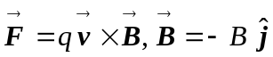 will provide the correct direction for each force. Using either force, say 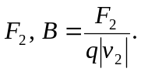
b) 